About Hacking Club
Hacking Club is a platform to learn cybersecurity, an incredible resource if you don’t know where to start. In addition to vulnerable machines, you have access to classes and challenges to practice your skills and access to an exclusive community to play and challenge yourself.

The best part about Hacking Club is that it is very hands-on. If you are new to hacking, give it a try.

Introduction
This write-up refers to the INTEGRATOR machine. If you require support, please open a ticket in the support channel on the Discord server.

Nmap Scan:
As a first step, we need to determine which services are running in the background and which ports are open. So, we will use a tool called nmap.
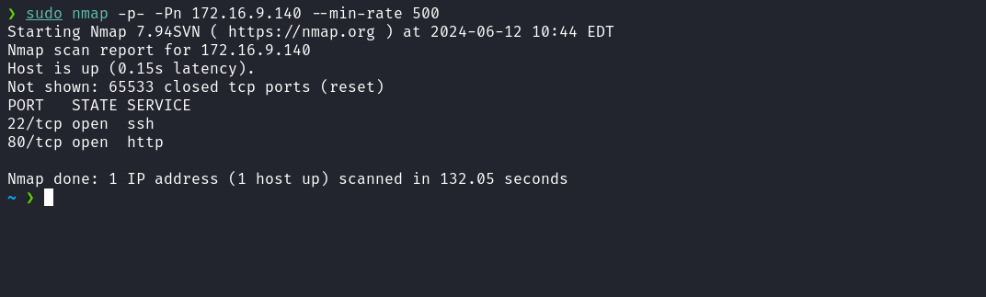
We observe the presence of port 80 hosting a web service and port 22 corresponding to SSH.
When accessing port 80 of the web service, an automatic redirection occurs to the domain: integratorhub.hc

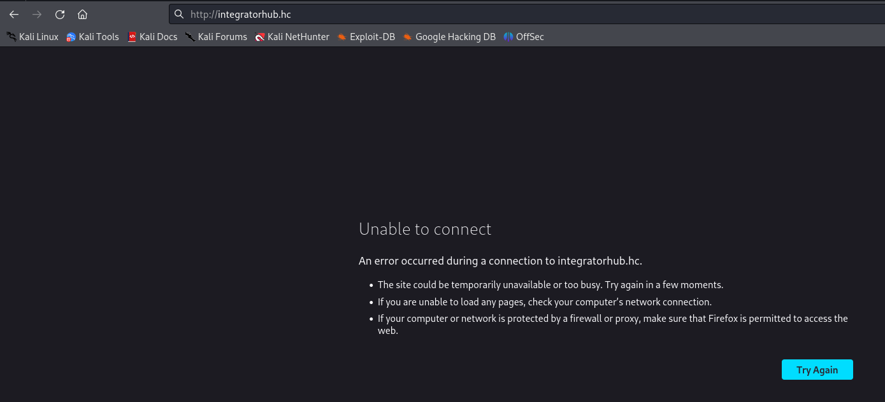
To resolve this, we need to map the IP address to the domain name by adding an entry to the hosts file, as shown in the image below.
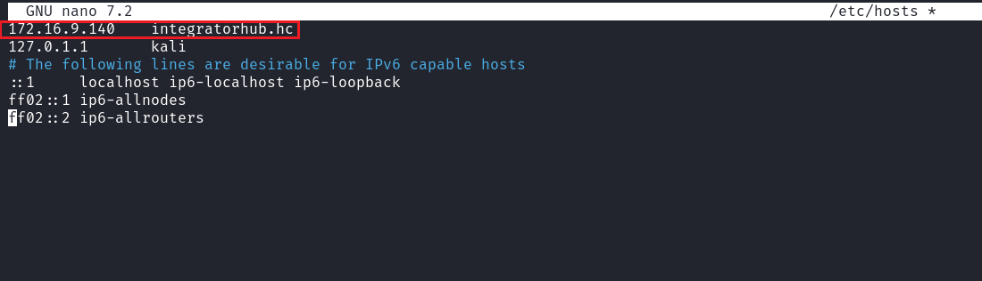
After accessing the application again, we are presented with a login page, but we do not have credentials. We also notice the presence of a "Recover Password" link.
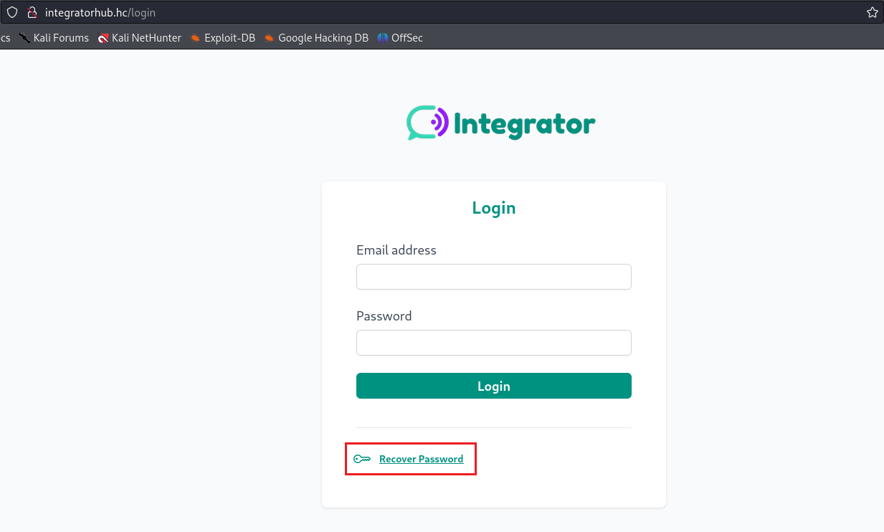
When accessing the "Recover Password" link, we are prompted for an email associated with IntegratorHub. Since we do not have this email, we can perform fuzzing to find a file that may contain an associated email address.
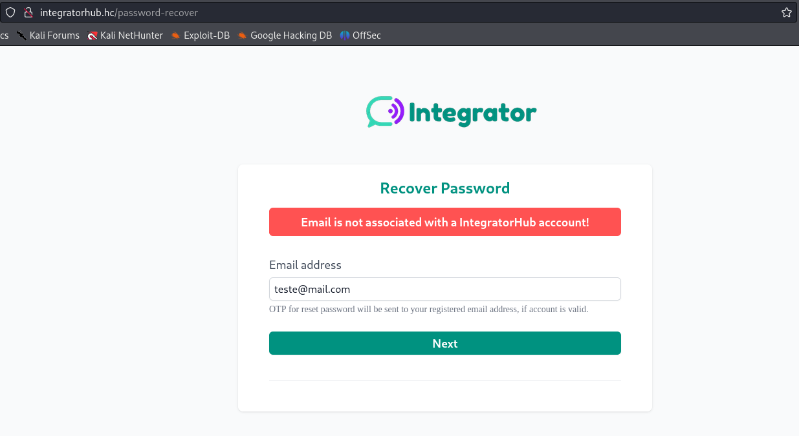
By performing fuzzing with the wordlist "fuzz-Bo0oM.txt" from SecLists, we discovered the file: config.json.
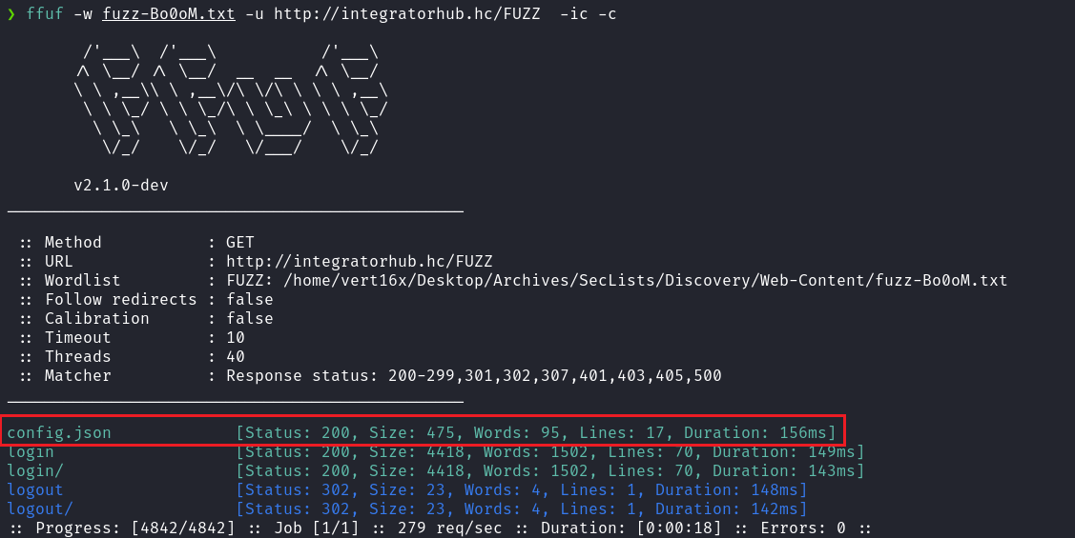
Inside config.json, we found the email: admin@integratorhub.hc which we can use.
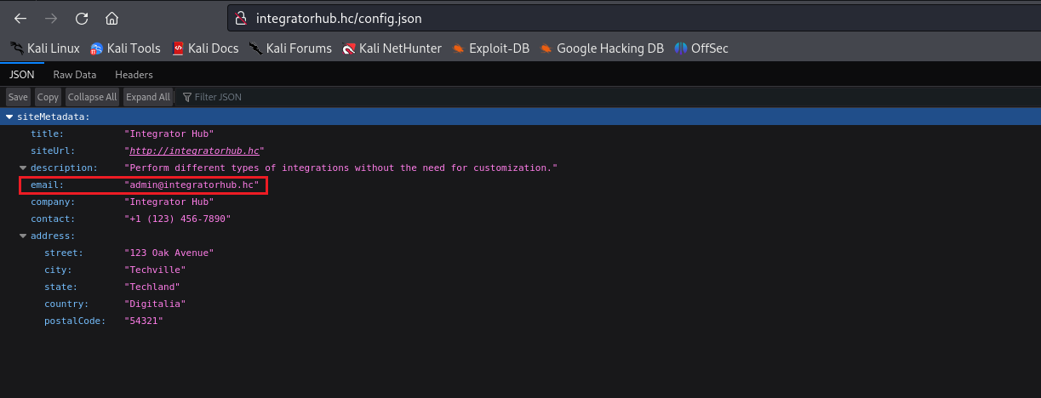
After using the discovered email, we are prompted for a 4-digit numeric OTP code, sent to the corresponding email address.
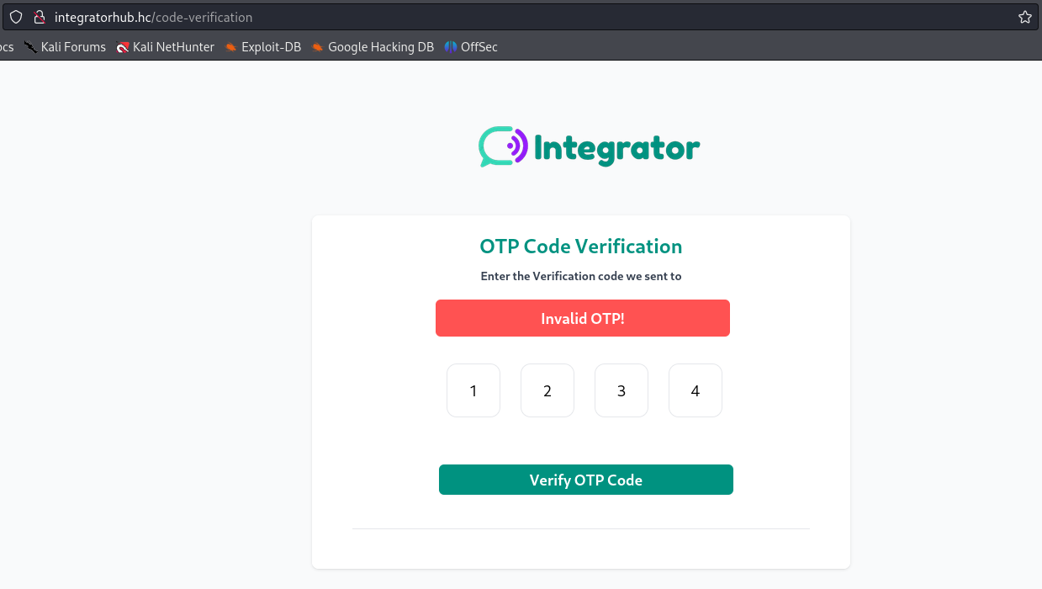
Since we do not have access to the OTP sent to the email, we can attempt a brute-force attack. To do this, we intercept the request after providing a code.
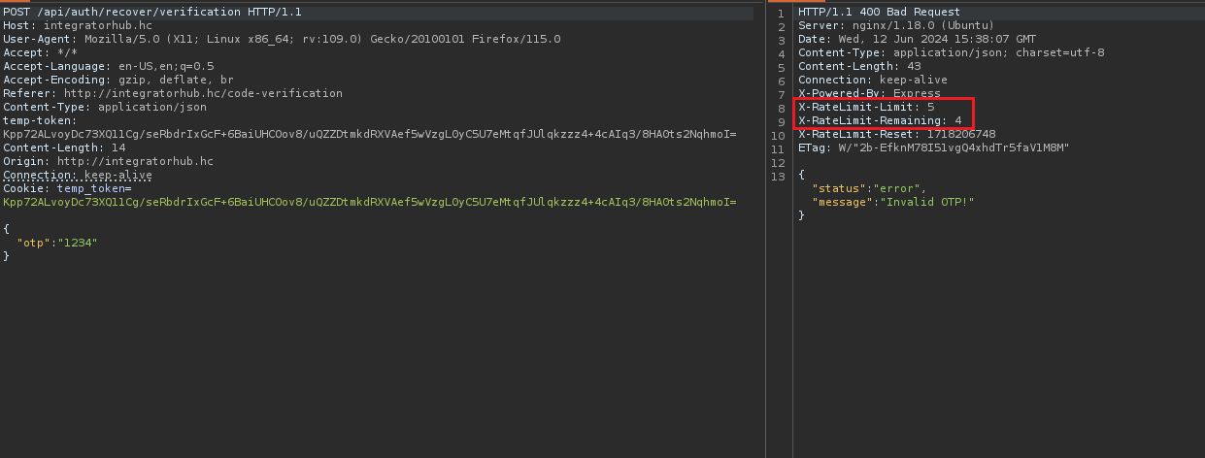
We observe that brute-forcing is not possible due to the implementation of rate limiting in the application.
An alternative exploitation technique we can use is a Type Confusion attack. This attack occurs when a variable does not have an explicitly defined type in the code, allowing it to assume any type such as number, string, object, array, etc.
In the code, the variable otp is expected to always be a string when receiving the OTP. However, since there is no strict type enforcement, we can transform it into an array. This scenario allows us to bypass the OTP mechanism.
For a deeper understanding of this vulnerability, it is recommended to watch the lessons in the Hacking Club Advanced Exploitation (Web) module, including:
- Type Confusion Attack – Filter Bypass
- Type Confusion Attack – ORM (Mongoose)
- Type Confusion Attack – ORM (Prisma)
With this knowledge, we can develop a script that generates an array from 0000 to 9999:
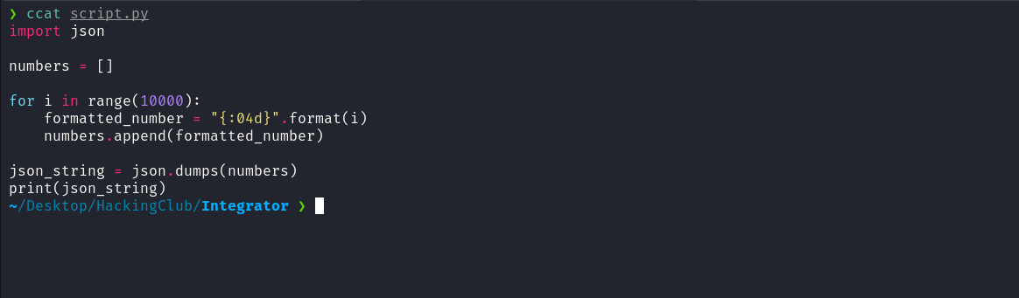
After providing the array containing all codes, we successfully bypass the OTP.
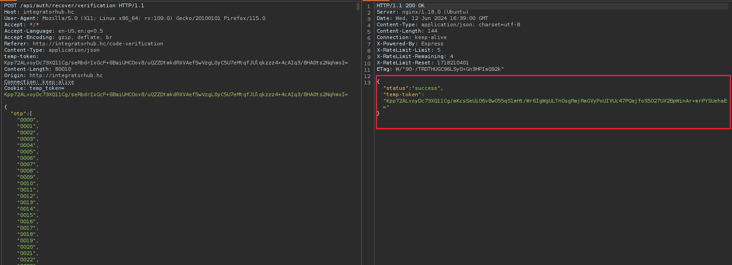

After the successful bypass, we gain access to the /reset-password route to change the password.
There are two possible approaches:
- Analyze the JavaScript file send-otp.js and replace the temp-token with the new token.
- Intercept the request again, insert the array, and forward it to continue the request flow.
We will choose option 1, since we already have the token available.
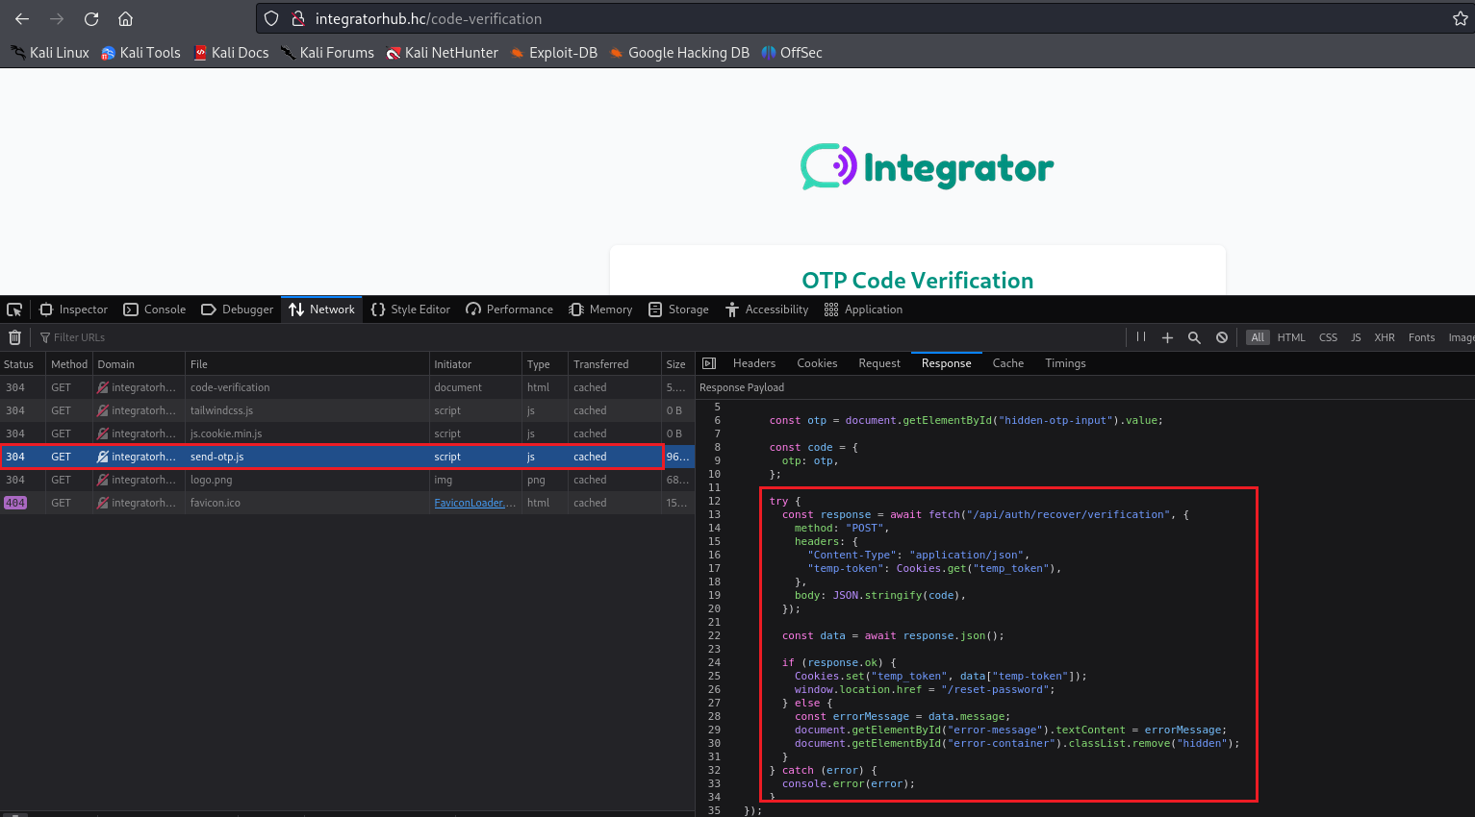
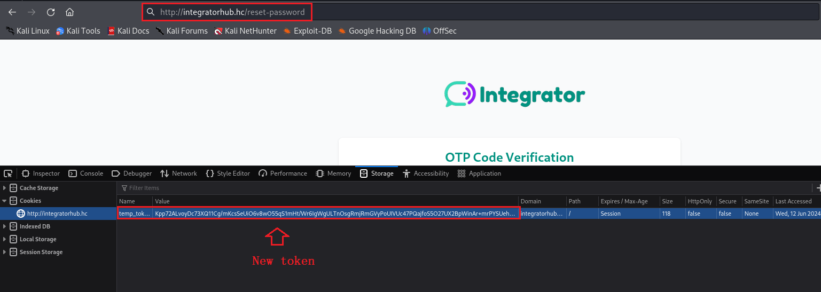
After replacing the token and accessing /reset-password, we are able to change the password.
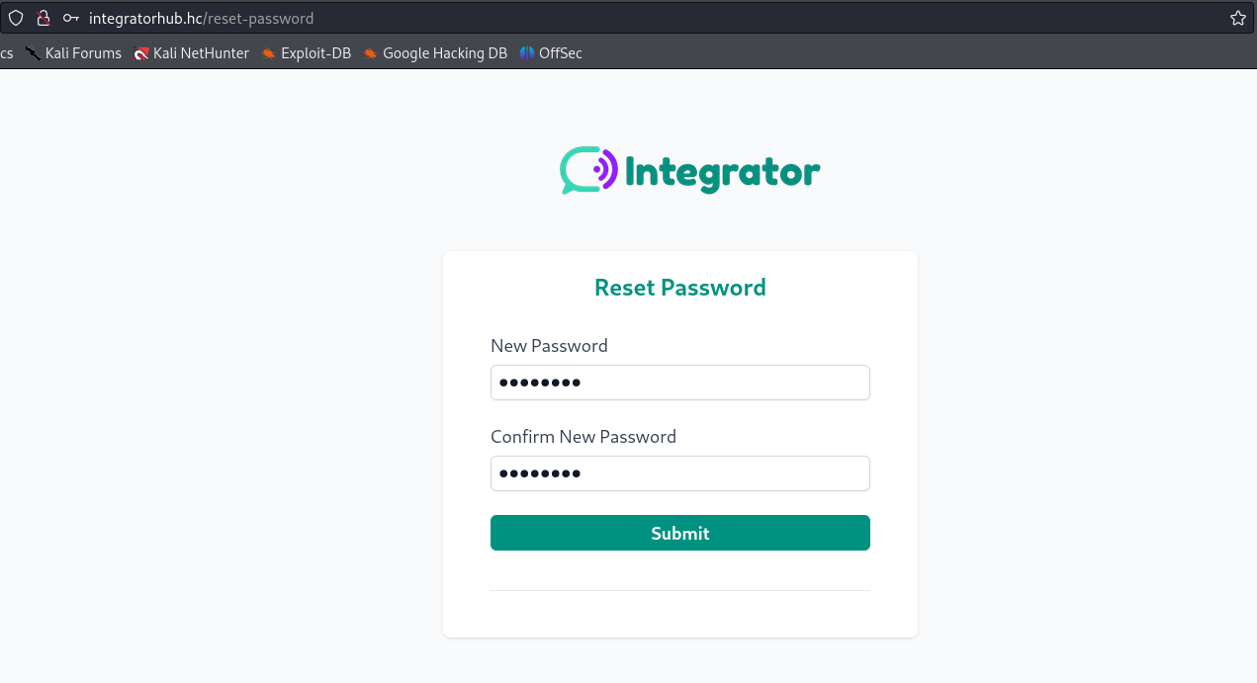
After logging into the application, we can access /workflow.
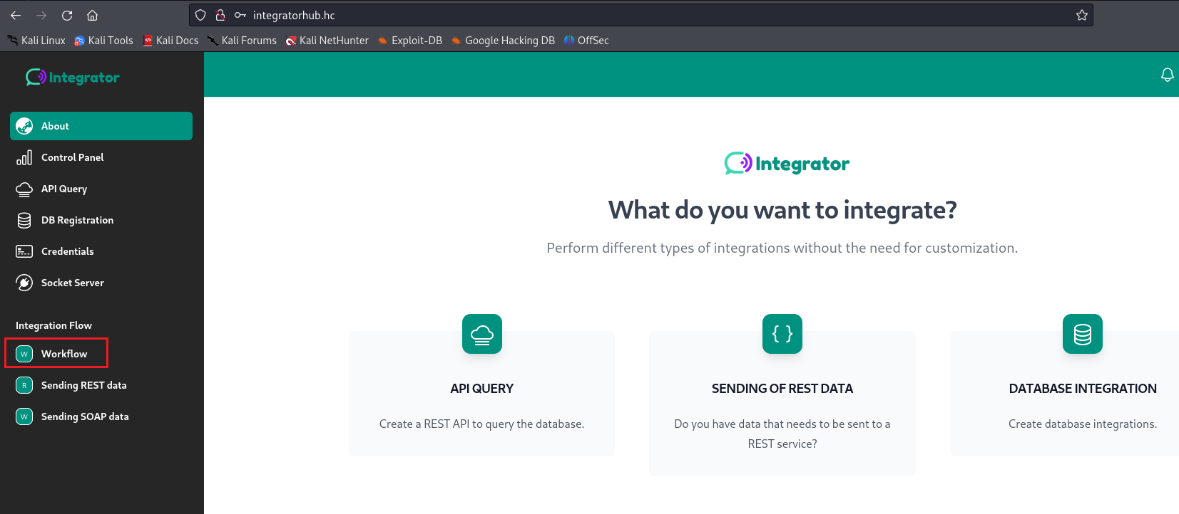
On this page, we observe the ability to execute JavaScript code. However, reading the description, we notice that the code will run in a controlled environment (sandbox) and that it uses the vm2 library.
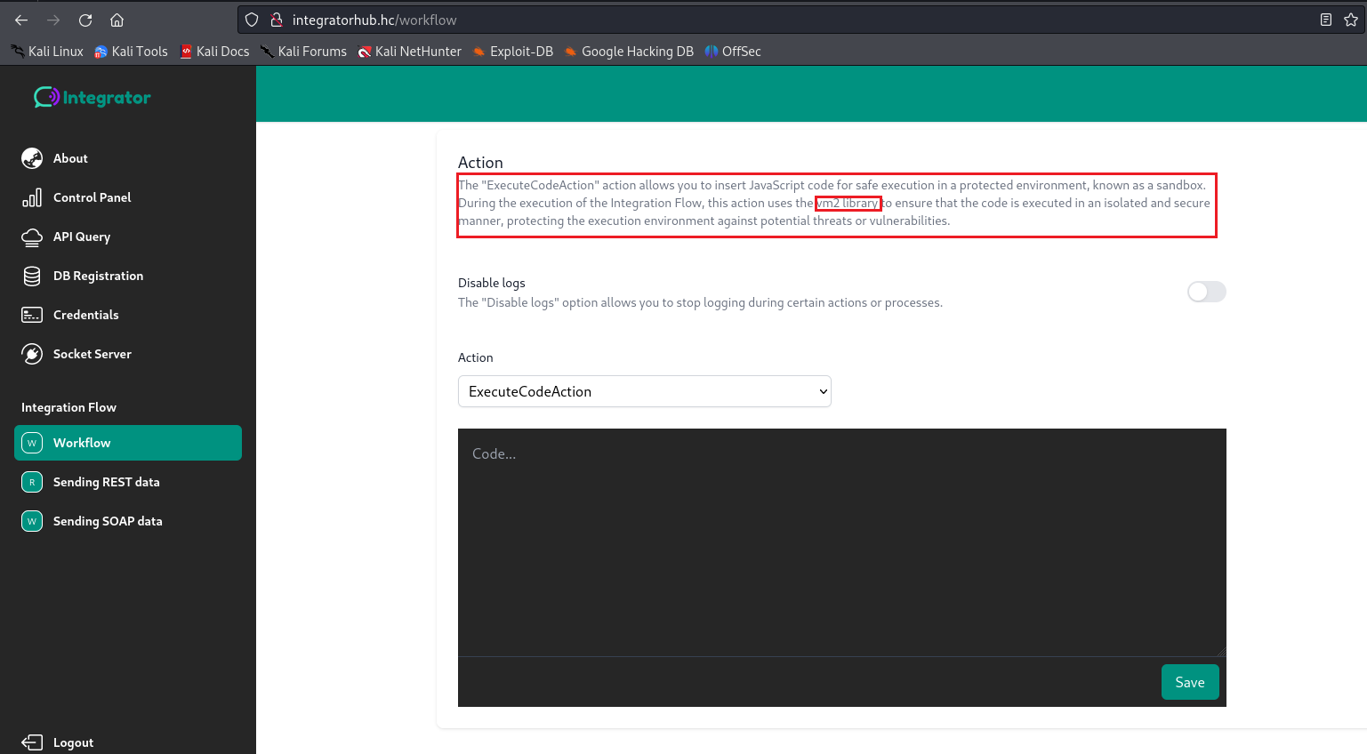
After researching this library, we identified the existence of CVE-2023-32314 – Sandbox Bypass. The vm2 library is a sandbox capable of running untrusted code, provided it uses allowed built-in Node modules.
Affected versions of this package contain a Sandbox Bypass vulnerability caused by abusing unexpected host object creation via Proxy with malicious code. Exploiting this vulnerability allows an attacker to obtain remote code execution privileges on the host running the sandbox through the Function constructor.
https://security.snyk.io/vuln/SNYK-JS-VM2-5537100
We can use the Proof of Concept (PoC) from the referenced link to execute JavaScript code that runs the command id.
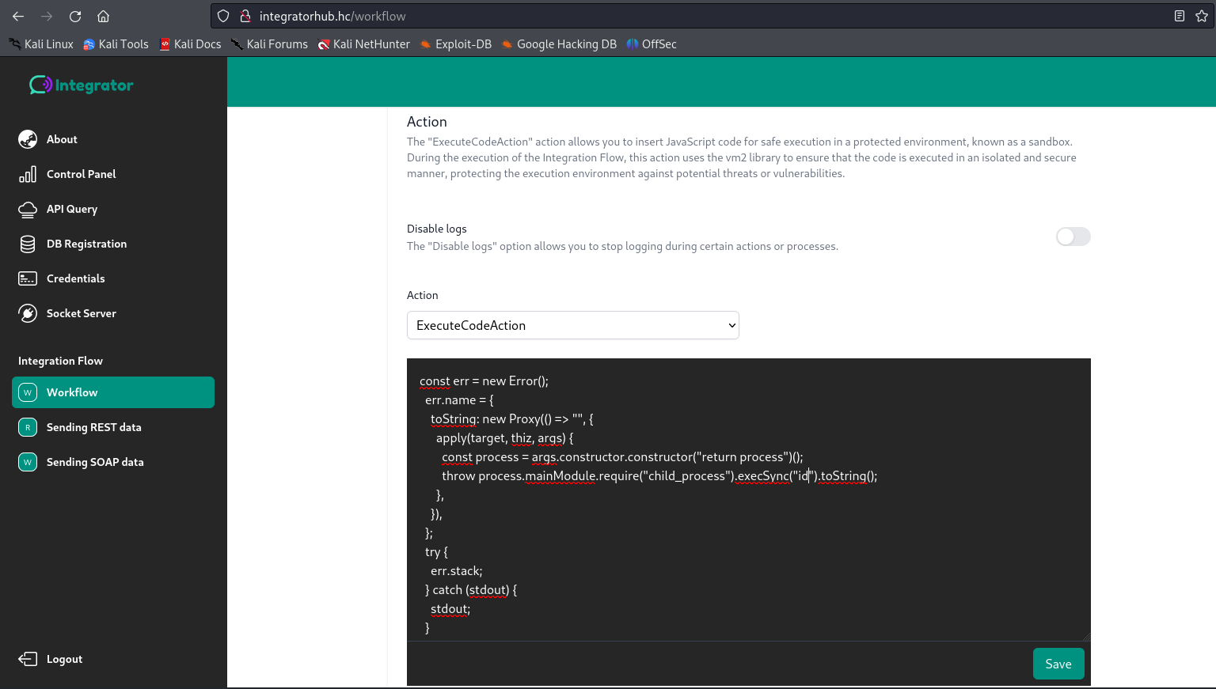
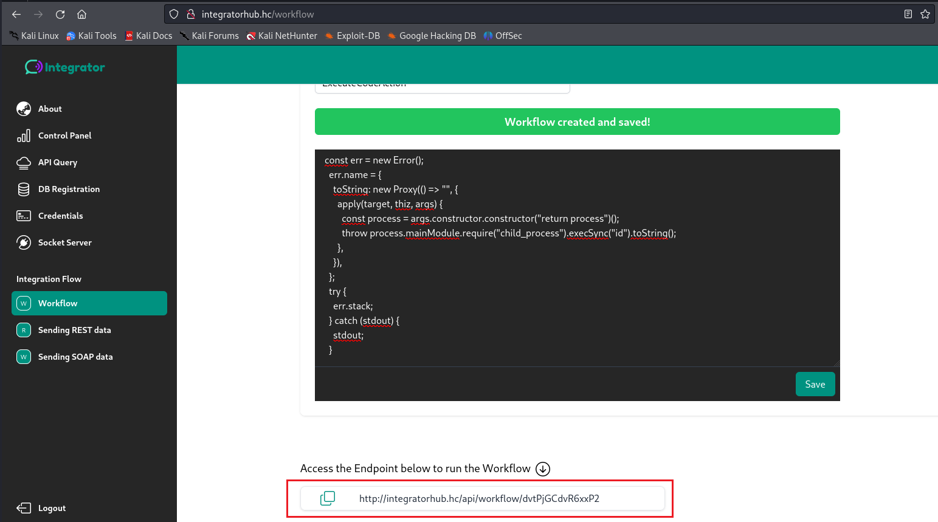

After accessing the generated link following the save operation, we can view the output of the id command.
Based on this, we create new code, this time passing a reverse shell payload.
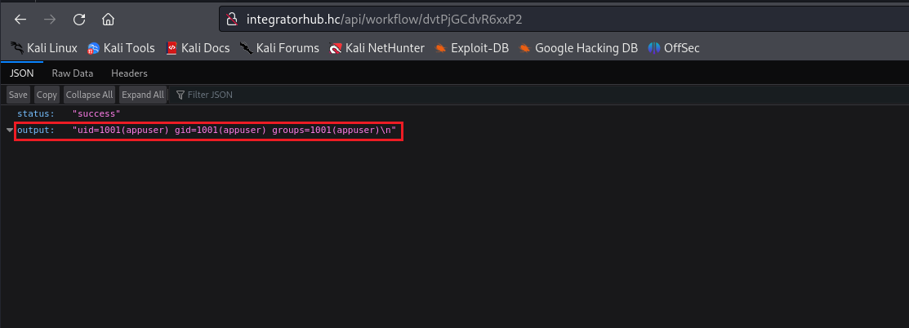
Netcat listener to receive the connection:
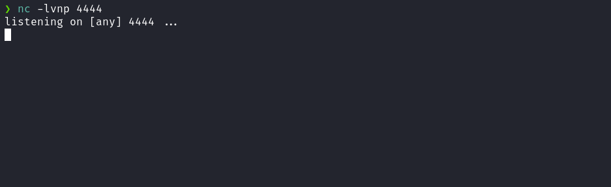
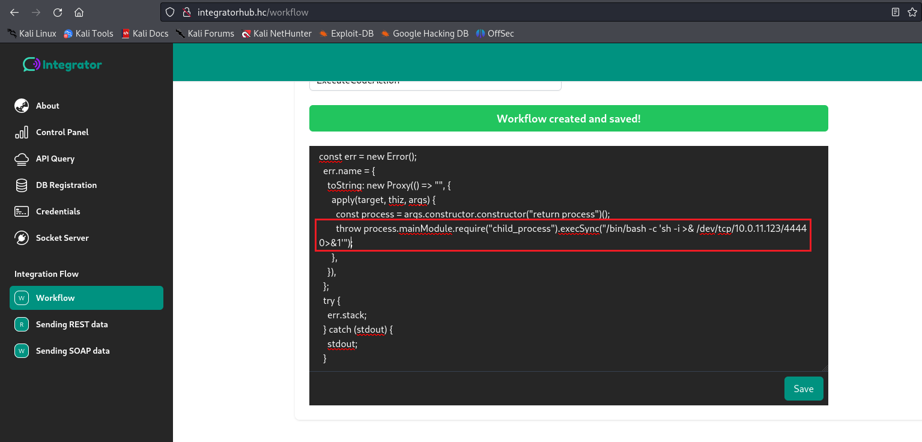
Accessing the new generated link, we receive the shell.

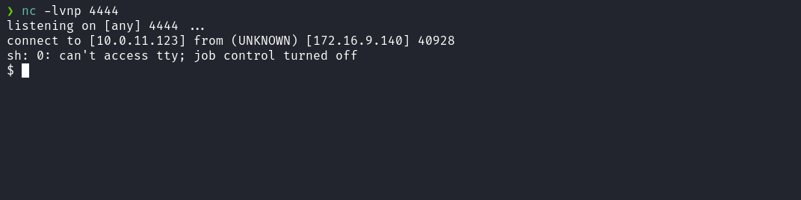

Upgrading the simple shell to a fully interactive TTY:
script /dev/null -c bash
Ctrl+Z
stty raw -echo;fg
export TERM=xterm

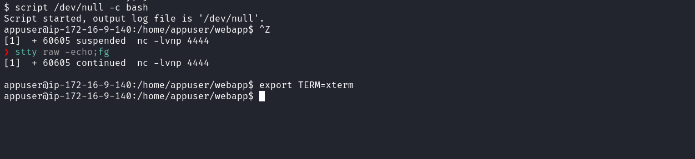
Accessing the home directory of user appuser, we obtain the first flag.
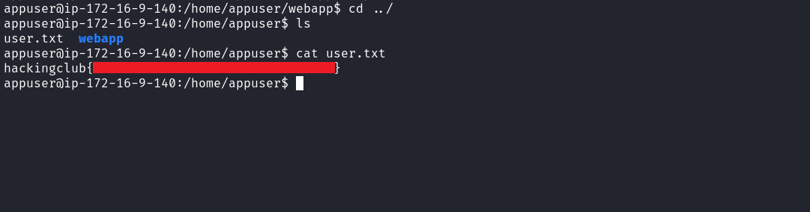
Running ss -nlapt we identify that port 3001 is running locally.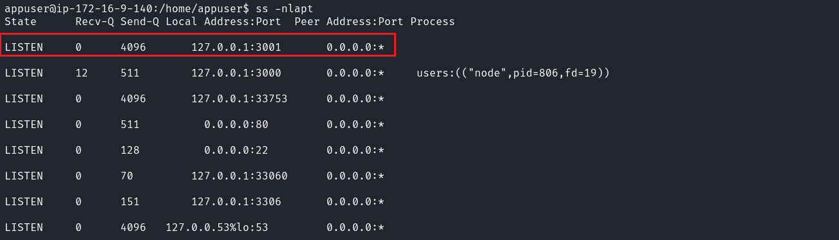
By executing curl 127.0.0.1:3001 we confirm that it is a web application.
We decide to use chisel to forward port 3001 from the server’s localhost to our machine, allowing browser access.
https://github.com/jpillora/chisel
On our local machine:
./chisel server -p 9000 --reverse
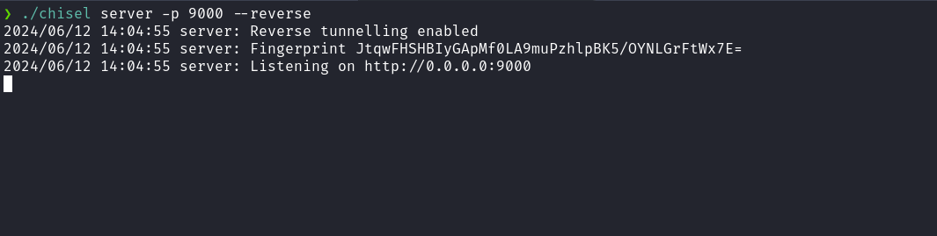
On the target server:
./chisel client <IP-VPN>:9000 R:3001:127.0.0.1:3001
Accessing the application in our browser, we encounter a login page requesting credentials. We can review previously accessed application files and attempt a Password Reuse attack.
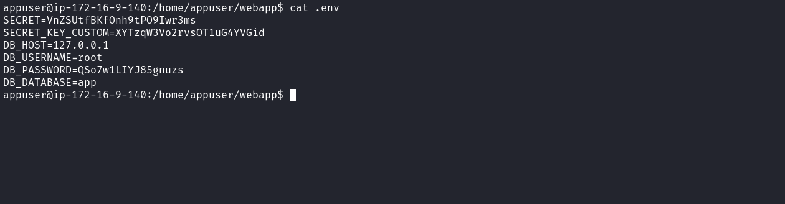
Reading the .env file, we identify credentials that can be reused.
Using root:QSo7w1LIYJ85gnuzs, we successfully log into the application.
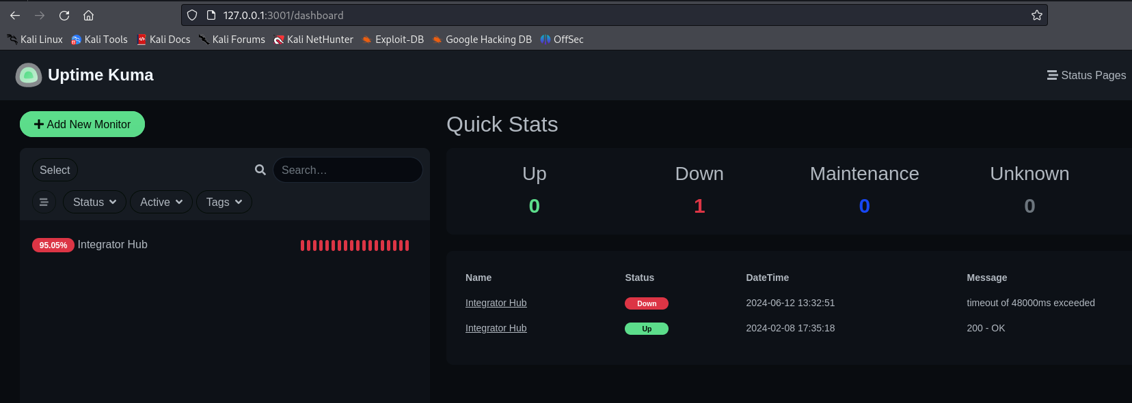
Accessing /settings/about we identify the Uptime Kuma version 1.23.2.
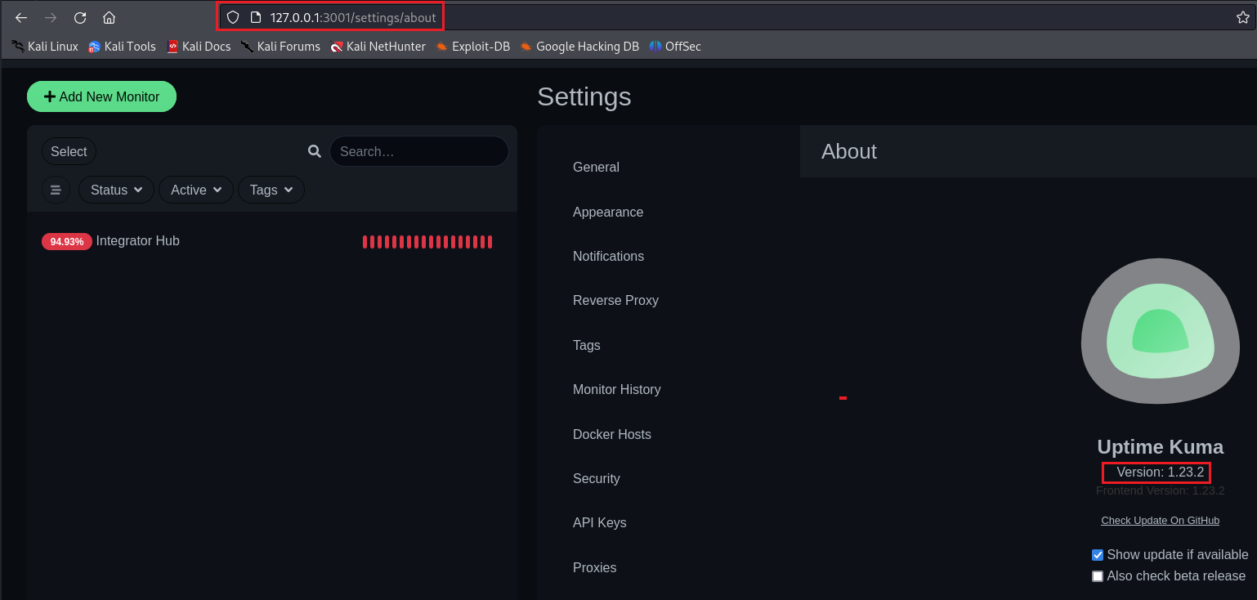
After researching this version, we identify a vulnerability:
Authenticated Remote Code Execution via TailscalePing
Important note: Since the application is running inside a container, the "Tailscale Ping" type is hidden. However, we can intercept WebSocket messages and set the isContainer parameter to false.
https://github.com/louislam/uptime-kuma/security/advisories/GHSA-hfxh-rjv7-2369
We click "Add New Monitor", intercept the request, and modify isContainer = false
This enables access to the TailscalePing type.
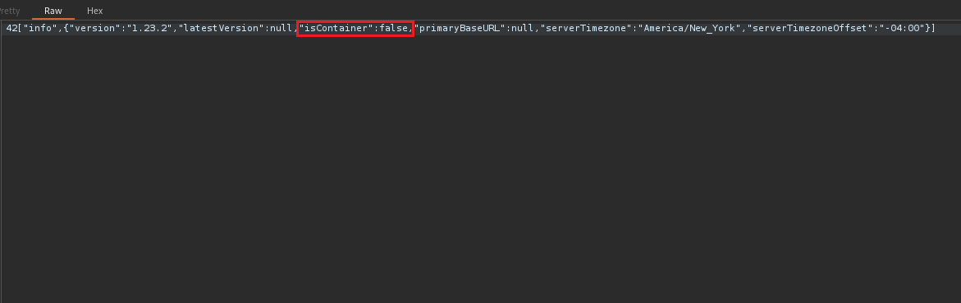
Afterward, we remove the pattern tag from the hostname field, which uses regex filtering, allowing us to insert our reverse shell payload.
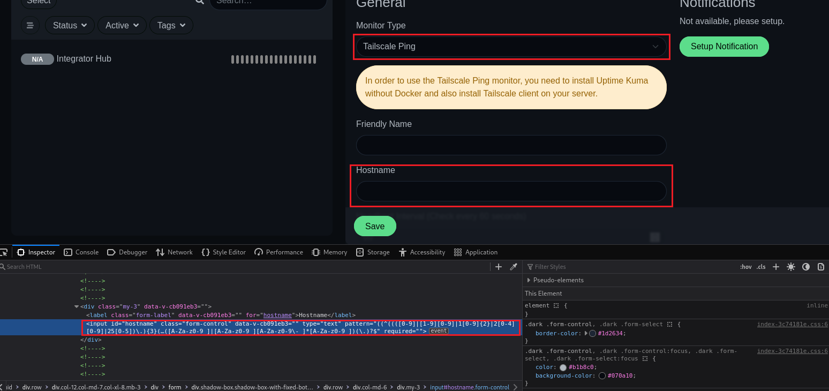
Netcat listener to receive the reverse connection:

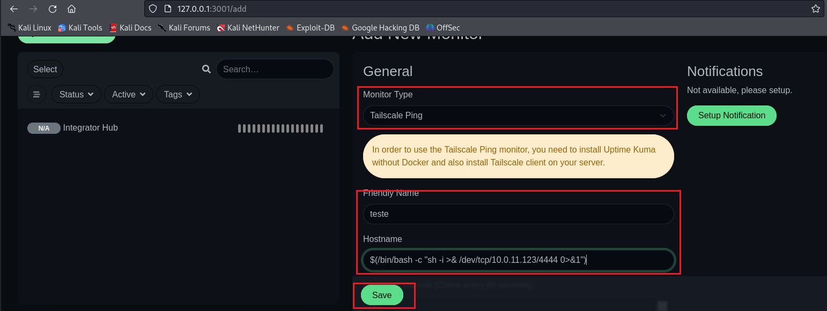
After clicking Save, we receive a shell.
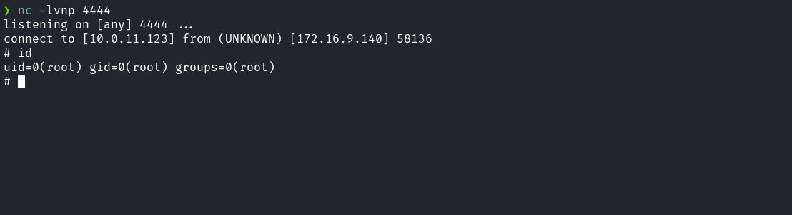
Since we are inside a container, we attempt a Docker escape. One possible method is mounting the host filesystem inside the container (e.g., /mnt). This is only possible if the container was started with --privileged=true
We can use df -h to list partitions and disk usage.
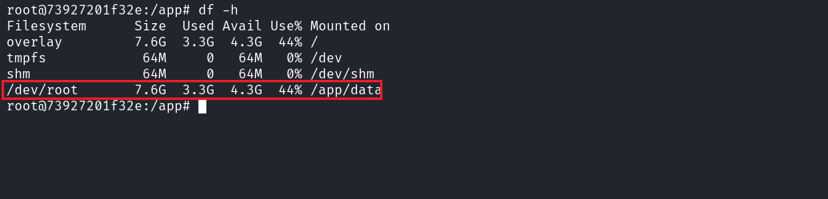

After identifying the correct device, we mount it:
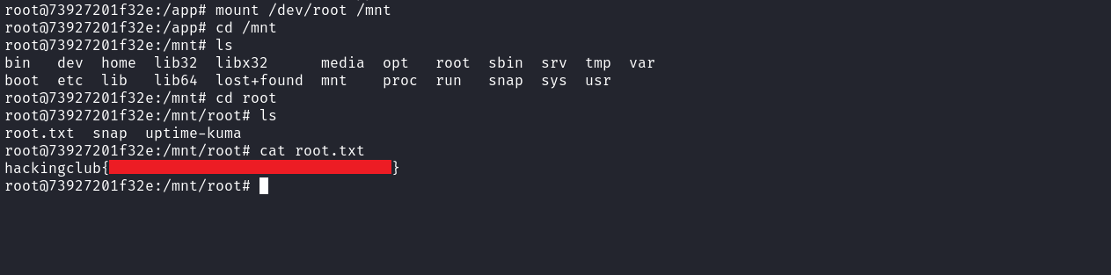

And we successfully retrieve the final flag.

